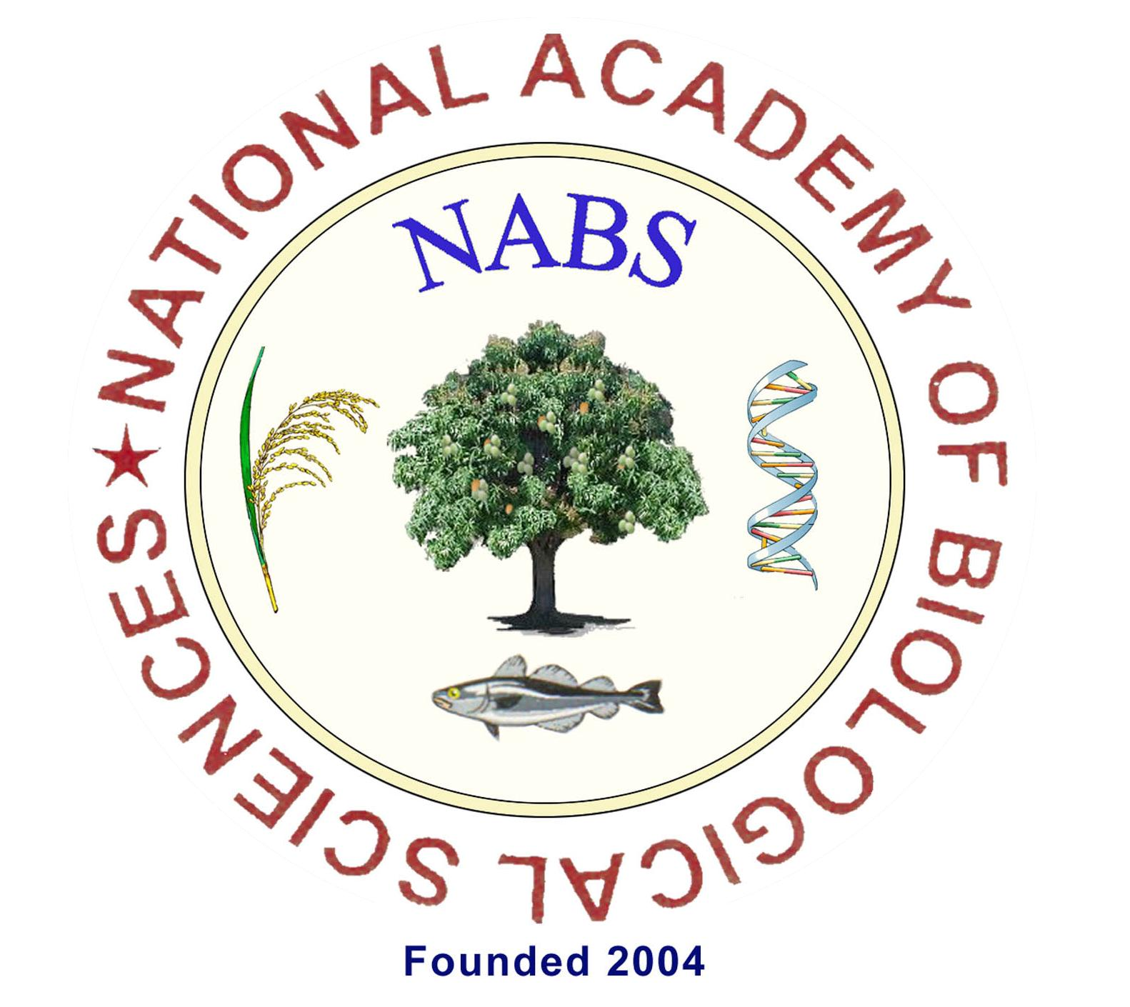
NATIONAL ACADEMY OF BIOLOGICAL SCIENCES
[NABS]
Application for
NABS-Best Research Paper Awards-2023

Guidelines
- Please read the guidelines carefully before filling up the Application and strictly follow the guidelines attached.
Please fill the columns below
Name of the applicant
Membership No. | : | LM-  PLM-
Indicate under which category you are applying for the award (Recognized subjects of NABS are given below) – Tick mark
Agriculture & Forestry Science (AFS | :
Basic Science (BS)
Veterinary & Fishery Science (VFS)
Food Science (FS) | :
Date of birth [DD-MM-YYYY] | :
Age as on 1st December, 2023
Registration and Processing Fee  Only online transfer permitted  Provide evidence for online transfer | : | Rs. 500/- [Rupees Five hundred only]
 | : | Rs. 500/- [Rupees Five hundred only]
For official Use only
Whether full paper received with reprint | :
Whether forwarded by competent authority | : | YES / NO
Date of receipt of the application | :
Whether the member is eligible for further scrutiny | :
Give reasons for rejection | :
Eligible or Not Eligible

Signature of Secretary
Application for
NABS- Best Research Paper Awards for 2023

Fix your recent PP size color photograph without your signature

1. | Name of the Applicant  (in BLOCK LETTERS) | :
2. | Name of Father / Husband
3. | Gender (tick mark) |  | Male  Female
4. | Date of birth  (DD-MM-YYYY) | :
5. | Age  [completed years as on 01-12-2023] | :
6. | Life Membership Number (or)  Provisional Life Membership Number (whichever is applicable) |  | LM-  PLM-
7. | Indicate under which category you are applying for the award (Recognized area /subjects of NABS are given below)- Tick mark | : | Tick mark against the recognized subjects.  [Only one paper shall be submitted under each category of subject recognized by NABS]
 | - Agriculture & Forestry Science (AFS) | :
 | - Basic Science (BS)
 | ii. Veterinary & Fishery Science (VFS) | :
 | iii. Food Science (FS) | :
8. | Present official position | :
 | Official address | :
 | Mobile / Phone with STD code | :
 | E-mail | :

9. | Address (Residence) |  | :
 | Mobile / Phone with STD code |  | :
 | E-mail |  | :
10. Academic qualifications
Degree |  | University / Institution |  |  | Year | Distinction
M.Sc.
Ph.D.

11. | Research Publications for the award
- List the Publications you have submitted for the award; should be within THREE YEARS –Not before 2020
- Provide Reprints of listed publications
Sl. No. | Publications (Authors’ names, title, journal, volume, page nos., year of publication) | Category of subject | NAAS rating | SNIP/IF by SCOPUS | SNIP/IF by ISI
1
2
3
4
5

Certificate to be furnished by the Applicant
Certified that the information furnished are true to the best of my knowledge and belief. The co-authors are aware of the details furnished above. I will abide by the decisions of TRC of NABS.
Place: | Signature with designation
Date: | Signature with designation

Check List
[To be attached along with Application as a separate page]

No. | Check for |  | Tick Mark
1. | Whether section name under which application is to be considered- furnished?
2. | Whether Life Membership / Provisional Life Membership Number is furnished?
3. | Whether age proof is enclosed?
4. | Whether Registration & Processing Fee of Rs.500/ is paid online with evidence enclosed?
5. | Whether the application is Forwarded and signed by competent authority?
6 | Whether the PP size photo is affixed on the application as specified?
7. | Whether necessary supporting evidences are enclosed and serially numbered? [Annexure]
8. | Whether content page is prepared and all pages are serially numbered?
9. | Whether the cover is superscribed with “Application for  NABS-Best Research Paper Award-2023"?
Signature:

Date:
---------------------------------------END OF APPLICATION---------------------------------------

