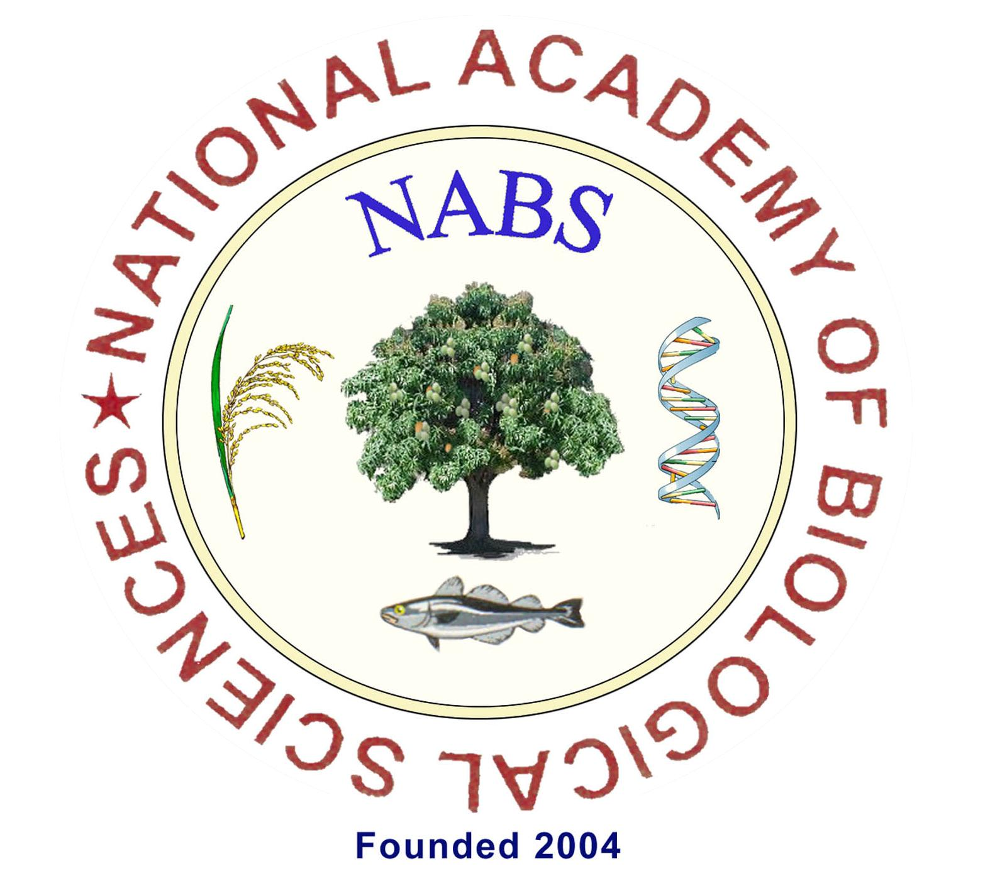 | Proposal to organize  Prof. SK Memorial NABS-Lecture Workshop  [Application]

1. | Name of the Institution with full address with E-mail ID of the institution) | :
1.a. | Name of the University to which the Institution is affiliated | :
1.b. | Name of the Principal / Dean of the College with mobile number/E-mail ID | :
2. | Name of the Department willing to organize the Lecture Workshop | :
3. | Proposed topic of the Lecture Workshop(Subject to approval by NABS)
4. | Name and full address of the convener with mobile number & E-mail ID. | :
5. | Is the proposed convener is a Member or Fellow of NABS? | :
6. | Expertise available in the Department [List names and field of specialization] | :
7. | Participating Institutions  (including the host institution)  List the institution(s) | :
8. | Proposed number of students/teachers  (Not exceeding 100 in all) | :
9. | Any resource persons you would like to suggest?  (subject to approval by NABS) | :
10. | Proposed Chief Guest for Inaugural and Valedictory function | :
11. | Budget estimate  (Provide in a separate sheet along with the application) | :
12. | Signature of the Convener with date | :
 | Countersigned by the HOD & Principal/Dean of the Institution  (affix official seal) | :

