Guidelines for Applying to NABS
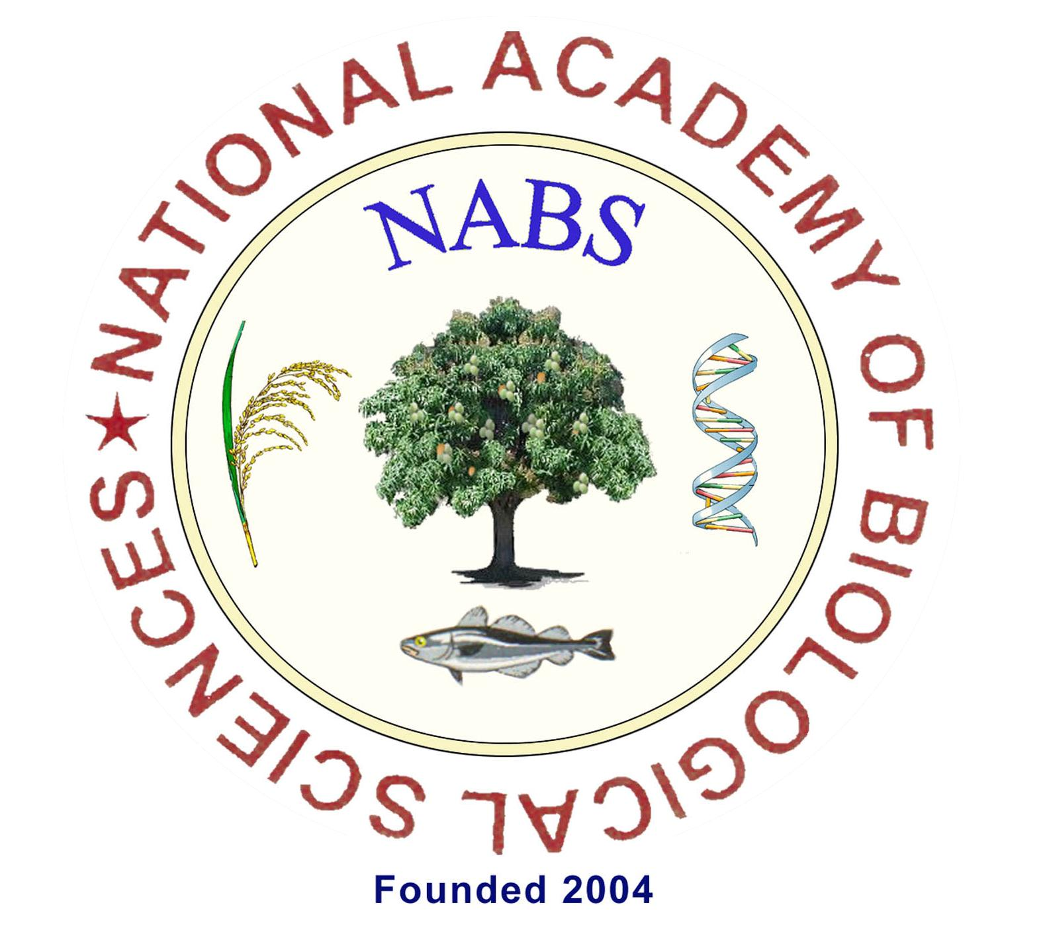
Fellowship / Awards
[For Election Year 2022]
____________________________________________________
- GENERAL INFORMATION
- Types of Fellowship & Awards
Sl. No. | Name of Awards | When introduced
1 | Fellowship | 2005
2 | Associate Fellowship | 2009
3 | NABS-Best Woman Scientist Award | 2010
3.1. | Dr. E.K. Janaki Ammal Memorial NABS-Best Woman Scientist Award  [Under Agriculture & Forestry Sciences]
3.2. | Dr. Kamala Sohonie Memorial NABS-Best Woman Scientist Award  [Under Basic Sciences]
3.3. | Dr. Sakkhubhai Ramachandran Memorial NABS-Best Woman Scientist Award  [Under Veterinary & Fishery Sciences]
3.4. | Dr. Asima Chatterjee Memorial NABS-Best Woman Scientist Award  [Under Food Sciences]
4 | NABS-Best Research Paper Award | 2012
4.1. | Prof. G. Rangaswami Memorial NABS-Best Research Paper Award  [Under Agriculture & Forestry Sciences]
4.2. | Prof. T. S. Sadasivan Memorial NABS-Best Research Paper Award  [Under Basic Sciences]
4.3. | Prof. C. M. Singh Memorial NABS-Best Research Paper Award  [Under Veterinary & Fishery Sciences]
4.4 | Dr. V. Subrahmanyan Memorial NABS-Best Research Paper Award  [Under Food Sciences]
5 | NABS-Young Scientist Award  Dr. G. N. Ramachandran Memorial NABS-Young Scientist Award | 2013
6 | NABS-Best Scientist Award | 2014
6.1. | Dr. B.P. Pal Memorial NABS-Best Scientist Award  [Under Agriculture & Forestry Sciences]
6.2. | Dr. G. S. Venkataraman Memorial NABS- Best Scientist Award  [Under Basic Sciences]
6.3. | Dr. V. S. Alwar Memorial NABS- Best Scientist Award  [Under Veterinary & Fishery Sciences]
6.4. | Dr. Smt. Rajammal P. Devadas Memorial NABS- Best Scientist Award  [Under Food Sciences]
7 | NABS-Leadership Award  Prof. M. S. Swaminathan NABS-Leadership Award | 2014
- Applicant’s wrapper page
- Write the Name of the Award for which the application is made
- Write the subject under which the application is made
- Mention the Election Year
- Provide your full name as it should appear in Citation/Certificate
- Provide your Life Membership Number

Example
[Use bigger font- bold]

NABS-Best Scientist Award
Dr. B.P. Pal Memorial NABS-Best Scientist Award
[Under Agriculture & Forestry Sciences]

Election Year: 2022
Dr. T. Marimuthu
LM-021-2019

- Eligibility Criteria to apply for Awards & Fellowship
- Common criteria:
- Only Life Members of NABS can apply for any award / Fellowship.
- All life members of NABS who have completed 30 years as on 1st December, of the Election Year and have completed a cooling period* of SIX months are eligible. [*From the date of enrollment as Life member, SIX months should have been completed as on 1st December of the Election Year]. However, the age limit varies with the type of award- Please see the Table-1 below
- Provisional Life Members are NOT ELIGIBLE to apply for Fellowship / Awards except for NABS-Best Research Paper award. No cooling period is required for NABS-Best Research Paper award.
- In an Election Year, an eligible member can apply either for Fellowship or for one Award ONLY.
Table-1: Name of Award/ Fellowship, Registration and Processing Fee,
Validity and Age limit

S. No. | Name of Awards | Age limit  [completed  years] * | Registration &  Processing Fee  [INR} | Validity of application & Processing Fee
1 | Fellowship | 30 & above | 3000 | N+2
2 | Associate Fellowship | 30 & above | 3000 | N+2
3 | NABS-Best Woman Scientist Award | 30 & above | 3000 | N+2
4 | NABS-Best Research Paper Award | 40 & below** | 500 | N
5 | NABS-Young Scientist Award | 40 & below | 3000 | @N+2
6 | NABS-Best Scientist Award | 30 & above | 3000 | N+2
7 | NABS-Leadership Award | 50 & above | 3000 | N
*As on 1st December of Election Year
** Both Life Members & Provisional Life members
@ Subject to age limit
IMPORTANT NOTE: Though the validity of application (without paying Registration & Processing Fee for the second & third year) for reconsideration in second and third year remains, fresh updated full application needs to be submitted EVERY year. Just submitting the additional information is not sufficient and if only additional information alone is submitted, the application will not be considered for evaluation.

2. | Submission of nomination cum applications to the Secretariat of NABS
i. | - Only one copy of application needs to be submitted. No soft copy is required.  - Duly filled nomination cum application shall be sent by Speed Post / Registered Post / Courier / in person by the proposer or by the candidate so as to reach the Secretary not later than 5:00 PM of 14 April, 2023  Prof. T. Marimuthu  Secretary, National Academy of Biological Sciences  C/o Dr. N. Mathivanan  Vice President, NABS (HQ) and  Director & Head , Centre for Advanced Studies in Botany  University of Madras, Guindy Campus  Chennai - 600 025  Tamil Nadu, INDIA  Mobile: 94436 73155 [Secretary, NABS)-Dr. T. Marimuthu  Mobile: 98402 53789 [Vice President (HQ)], NABS- Dr. N. Mathivanan
- Please inform the Secretary, NABS by e-mail about your dispatch of application (Date and mode of dispatch] to the below-mentioned E-mail:
- Prof. T. Marimuthu, Secretary, NABS
E-mail: secretarynabs@gmail.com
ii. | Super scribe the envelope as, “Nomination for Election of Fellow-2022” / "Nomination for Election of Associate Fellow-2022" or as the case may be.
iii. | Prescribed format of the application alone shall be used and type-written.  No hand-written copy will be accepted.
iv. | Please bind your nomination (Comb binding preferred).  No loose sheets are entertained as there are chances of missing them.
v. | Before sending the filled in application cum nomination, tick mark the check list and enclose it along with the application.
vi. | Prepare a content page and put before the Nomination Proposal.
vii. | Serially number all the pages starting from Nomination Proposal.
viii. | Enclose supporting evidences for every claim at the end of the application as Annexure(s) – for example: Evidences for Research Accomplishments, Educational Accomplishments and so on…which are to be serially numbered.
ix. | All supporting evidences will be only in English. In case, if any evidence is in other languages, the English version of the supporting evidence attested by a competent authority will have to attached.
3. | Eligibility: Age limit, Amount of Registration and Processing Fee, Validity of applications:  Please Vide Table No.1 of guideline
4. | Registration and Processing Fee [R & PF] [Non-refundable] shall be paid only online with proper evidence enclosed along with the application.  Nominee shall enclose evidence for having transferred the Registration & Processing Fee (Vide Table-1) online to the account of National Academy of Biological Sciences payable at Chennai before the last date of submission of application.  Name of Account: National Academy of Biological Sciences  SB Acct. No. 104 9697 8637  IFS Code- SBIN0011721).  State Bank of India, Valmiki Nagar branch, Chennai  (Branch code: 11721)
5. | Role of Proposer
i. | Who can propose the nomination?  Fellows of NABS / other Academies / Scientific Societies / President of Academies / Scientific Societies / Principal of College / Dean / Director / Registrar / Vice Chancellor of Universities can propose.
ii. | The proposer should restrict his / her observation only to the scientific / academic credentials of the nominee.
iii. | The proposer should clearly indicate the section and field of specialization in which the candidate is to be considered.
iv. | A proposer can nominate ONLY ONE member in a year. If he /she proposes more than one member, the application received first alone will be entertained; the other nomination will not be accepted.
6. | When the Application will not be considered?
i. | Without the remarks and signature of Forwarding Authority
ii. | Without the signature and remarks of proposer
iii. | Not received before the last date prescribed.  Note: Submission of soft copy before the last date will not be taken as the application was received before the last date.
iv. | Without the Registration and Processing Fee.
7. | Validity of Nomination cum Application  Please vide Table-1. of the guideline

- Check List- is attached along with Application
- Tick mark the checklist in appropriate column and put your signature

IV. TECHNICAL PART OF THE APPLICATION
PART-III ACCOMPLISHMETS
A. Research Accomplishments [Provide Evidence- the first page of each publication containing the title, authorship, journal name volume etc.]
- Fill the three columns in the format provided in the application under Research Accomplishments as given under:

S. No. | Publications (Authors’ names, title, journal, volume, page nos., year of publication) | NAAS rating | SNIP/IF by SCOPUS | SNIP/IF by ISI
1
2
20
- The applicants need to provide proof of the ratings of the journals in which they published. Page limit-1 page.
- The above details are essential to avoid the inclusion of predatory/open access journals that are not following stringent peer-review process.
- The mark distributions are as detailed below:

- First and corresponding author | : | 1 Mark
- Second and Third author | : | 0.5 Mark
- Authorship other than these two | : | 0.25 Mark
- Mark for impact factor NAAS 10 and above/SCOPUS 4 and above |  | 1 Mark

B. Educational accomplishments
- Number of books published: For evaluation purposes, Sole authored book – full marks (2marks); Edited books (multiple authors) Senior author gets full mark of 1; others will get half a mark (0.5) There can be maximum of six authors.
- A book should have a minimum of 200 pages with ISBN number.
- Number of students guided (Ph. D. only): The applicant’s name as guide should be mentioned in any proof that is submitted.
C. Externally Funded Scheme
Externally funded schemes completed
- List Regional / National / International projects completed in the last 10 years with a grant of Rs.10.00 lakhs and above as Principal Investigator.
- ICAR coordinated projects will not be considered.
- Provide evidence for the funding received. Keep the copy of the letter of sanction issued by the funding agency along with the copy of the communication of University / Institution / Organization.
- Multiple letters with the sanctioned amount over the period of the funding duration will not be accepted.

D. Crop varieties / breeds /products / technologies /patents
1. Agricultural Sciences: Crop varieties/Products/Technologies/Patents
Attach
Evidences: (Claim can be made in only one sub category. For example, if a variety released has been registered with PPV&FRA, marks will be given under patents)
- Varieties released by State/ Central Varietal Release committee, NBPGR for crop varieties/germplasms developed. Proof must be given to show that he/she was responsible for the varieties
- For tech products, include letter from Institute Technology Management Unit
[ITMU] in case of NARS (Institutes/ SAUs) besides other necessary proofs of publication to indicate the author’s credit.
- Evidence for Patent granted should be included where the authors name is mentioned.
d). Application sent for Patent will also be considered provided proper evidence is enclosed. Technology developed: Authenticated letter from respective institution’s official stating its usefulness/money generated out of the Technology transfer should be included.
Publications as proof of Technology developed will not be accepted
Number of patents obtained: Submit only those patents that are granted. Each patent will get full mark.
The Patent applied (for each patent applied 0.25 marks will be given) subject to a maximum of 4 patents applied.
The patent proof should contain the name of the applicant

2. Veterinary Sciences: Breeds/Products/Technologies/Patents
Attach Evidences:
- Certificate from The Director, National Bureau of Animal Genetic Resources (https://nbagr.icar.gov.in/en/home/) or any other recognized Govt. agencies
- For tech products, include ITMU letter besides other necessary proofs from ICAR/IVRI.
- Details about developed product being commercialized by Industries
- Patent applied /granted

3) Basic Sciences and Food Sciences:
Institution-Industry Collaboration (IIC)/h-index/Products/Technologies/Patent
Attach evidences:
- IIC demonstrating funds obtained, transfer of knowledge/technique/product (proof from the industry)
- H-index will be considered for those who do research where IIC is not possible.
- Sequence submission to GenBank-NCBI (Basic Sciences)

E. Other Academic Achievements
1. Awards / Medals/Fellows by reputed organizations
- Awards / medals / Fellowships received from reputed organizations/recognized societies will be considered.
- Awards and Medals should have been received from registered, well recognized academies/ Societies institutions /organizations / Universities / State and Central Governments/ National level professional societies, Best teacher, researcher or extension worker award, Young Scientist award, D. Sc., etc.
- Awards of ICAR, CSIR, DST, DBT, ICMR, NABS, NAAS, NAVA, NASI will also be considered.
- International awards like Humboldt, Fulbright, DAAD Fellowship and awards of DBT Overseas award, INSA award will also be considered.
- Awards / medals received during study periods are not considered.

2. Positions in Scientific Societies
- Positions held in Scientific Societies / Prestigious committees, Task Force, Office Bearers of Professional Societies / Academies; Editor of reputed Journals, etc., are considered.
- Being a member in a society / academy will not be considered.

3. Organizing Secretary of Conference / Seminar (National /International); Resource person of
National /International Training program will be considered.
- Training program-National or International level shall have a minimum of 7 days
4. Chairman in Tech. sessions of National / International Conference / Seminar
- Chairman of a technical session of National / International Seminar / Conference will be considered
5. Number of Special Trainings attended at National/ International level
- Number of special trainings (other than for higher studies) attended with a minimum duration of not less than 21 days at national / international level are considered.
- Nature of training and purpose should be mentioned
6. Number of Post Doc. Trainings attended. (National /International)
- The training period should be at least for not less than ONE YEAR
7. Foreign countries visited (other than attending Conference/Seminar)
- Number of special trainings (other than for higher studies) attended with a minimum duration of not less than 7 days at national / international level are considered.

F. Academic / Research Leadership
- Providing leadership in taking forward the research activities of his discipline, organizing summer / winter schools, organizing special skill trainings to teachers, students / organizing Seminars / Symposia / Conferences shall be considered.
- Provide appropriate evidence(s).

NABS-Young Scientist Award
Dr. G. N. Ramachandran Memorial NABS-Young Scientist Award
- Teaching experience: Minimum of ONE semester.
- An endorsement by the course faculty and Head of the department should be attached as a proof.
Prof. M.S. Swaminathan NABS-Leadership award
Criteria for judging Leadership award:
- Leadership in his/her respective domains of expertise
- Leadership in the Institutions of employment
- Leadership in the profession

The committee considers evidence that supports:
- Leadership in his/her respective domains of expertise
  - Individual National and International grants/funds to improve research and technology
  - Publications in peer-reviewed journals
  - Number of PhD scholars and Post-doctoral fellows trained
  - H-index
  - Teaching subjects in UG, PG, and PhD programs.

- Leadership in the Institutions of employment
  - Fostering the growth of institution through the applicant’s expertise. E.g., institutional grants, national and international recognition and awards to the institution, etc.

- Leadership in the profession
  - Leadership in areas of professional development within a national/international professional association or society. E.g., recognition of applicant’s work through Society awards, medals, etc.
  - Leadership in influencing change or new directions in the application of applicant’s expertise that benefits society. E.g., transfer of applicant’s expertise into a product or technology, etc.
  - Leadership in the creation of knowledge and collaborative scholarly work in the theory and practice of applicant’s expertise in higher education. E.g., applicant’s expertise is published in national/international books/chapters.
  - Organizing National Training in the applicant’s field of specialization
  - Organizing International Training in the applicant’s field of specialization
  - Organizing National / International Congress/ Conference
  - Organizing Vocational Trainings
  - Organizing Summer courses for Teachers

NABS-Best Research Paper Awards
- Publication should be within THREE Years before the date of submission
- A copy of ONLY ONE full published paper should be submitted.
- Applicant should be the Senior Author in the paper submitted for the award.
- Provide Impact Factor and data base for IF
The Score Card is uploaded in the website
It gives you an idea about the distribution of marks
Please do not fill the SC- It is meant for guidance only

V. ANNOUNCEMENT OF RESULTS
List of PROVISIONALLY selected applicants for all the awards will be uploaded in the website in the month of May.

VI. PRESENTATION OF AWARDS
PROVISIONALLY selected candidates have to give a brief presentation about his/her research accomplishments during the conference and receive the award in person.
Every Claim Supported by Correct Evidence Counts on Your Success
NABS Wishes You Success

